Girl’s Track and Field
State
2011
May 19- 21
Eastern Illinois University
Charleston, IL
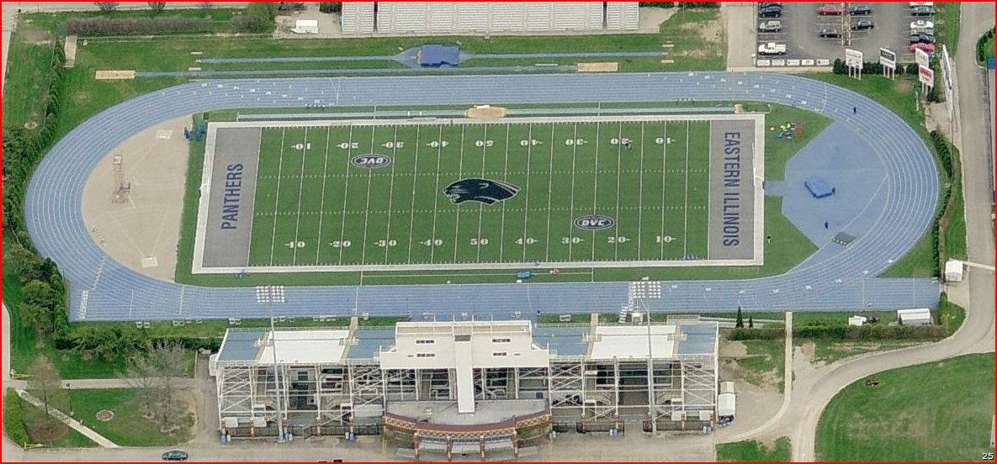

Girl’s Track and Field
State 2011
May 20- 22 at Eastern Illinois University in Charleston, IL

Where is EIU:

1. | Head north on S Kedzie Ave toward W 99th St  About 1 min | go 0.5 mi  total 0.5 mi

 | 2. | Turn right at W 95th St/US-12 E/US-20 E  About 4 mins | go 3.0 mi  total 3.5 mi

 | 3. | Turn right at S Halsted St  About 1 min | go 0.4 mi  total 4.0 mi

 | 4. | Turn right at the 3rd cross street onto W 98th Pl | go 308 ft  total 4.0 mi

 | 5. | Take the ramp on the left onto I-57 S  About 2 hours 54 mins | go 168 mi  total 172 mi

 | 6. | Take exit 190A to merge onto IL-16 E toward Charleston  Destination will be on the right  About 13 mins | go 8.1 mi  total 180 mi

600 Lincoln Ave, Charleston, IL 61920‎
O’Brien Stadium in next to Lincoln/Douglas/Stevenson Halls

Where are we staying: EIU dorm Rooms on campus

How do I contact the Coach:
Coach McArthur: 815-370-4147

Schedule
May 19-21 at Eastern Illinois University in Charleston, IL

Thursday:
- leave EPCHS @11:20 after 2nd Block from AD office
- Stop for Lunch
- Check in at EIU at 3:00, get ready for practice
- Practice @ 5:00 on the EIU Track
- Dinner at 7:30 at the Alamo in Mattoon (217) 234-7337
- Wal-Mart Run if needed
- Bed-Time: 9:30, Lights off 10:30

Friday:
- Wake-up: 7:00 Breakfast in cafeteria
- Weigh –in girls shot - 8:00 a.m. – 8:45 a.m.
- Compete 9:00 in AA Shot Put (warm-ups 8:30)
- Compete 9:00 in AA High Jump (warm-ups 8:30)
- Weigh –in girls discus- 9:30 a.m. – 10:15 a.m.
- Compete 10:30 in AA Discus (warm-ups 10:00)
- Lunch Jimmy Johns
- Watch Meet, Explore Vendors
- Dinner at Monical’s Pizza at 6:30 Charleston, IL (217) 348-7515
- Bed-Time: 9:30, Lights off 10:30

Saturday:
- Wake-up: Breakfast 8:00 in cafeteria
- Parades of Athletes at 9:00 wear EP apparel!!
- Compete/Watch State Finals
- Lunch at TBD
- Travel to home TBD

What to Bring?
May 19-21 at Eastern Illinois University in Charleston, IL

Clothes:
- Uniform
- Spikes/ Gym shoes
- Nice Shoes
- Warm-Ups
- Warm, Rain, and Cold gear
- Pajamas
- Hanging out clothes
- Nice clothes for dinners
- EP Mustang Apparel

Hygiene Products:
- Toothbrush
- Deodorant
- Hair brush
- Sunscreen
- Lotion
- Hair care products

Others Recommendations:
- Blankets
- Pillows
- Phone charger
- No TV in rooms, bring games (Uno, sorry, etc..)
- IPod and charger
- Towel
- Flip Flops for shower
- Spending Money
- Umbrella
- Camera
- Snacks
- Swimsuit

